
Welcome!
We are so glad you are here!
† indicates please stand if you are able

PRELUDE & CANDLE LIGHTING “A Joyous Prelude”
WELCOME & ANNOUNCEMENTS Kyle Houser

NFUMC MISSIONAL OUTREACH
“What a Friend We Have in Jesus” UMH 526, Vs 1&3
Blessing Baskets are for the benefit of
“Newark Food Closet”

†CALL TO WORSHIP Liturgist
Leader: Make a joyful shout to the Lord, all you lands!
People: Serve the Lord with gladness; come before His presence
with singing.
Leader: Know that the Lord, He is God; it is He who has made us, and
not we ourselves.
People: We are God’s people and the sheep of His pasture.
Leader: Enter into God’s gates with thanksgiving, and into His courts
with praise.
People: Be thankful to God, and bless His name. For the Lord is
good!
Leader: God’s mercy is everlasting,
People: And God’s truth endures to all generations.

†HYMN OF PRAISE “Lord, I Lift Your Name on High”
TFWS 2088

OPENING PRAYER (Unison)
Loving God, we give thanks and praise this day as we
gather to worship you. May the joy in our hearts be overflowing
as we seek your face and receive a fresh outpouring of your
Holy Spirit. May we recommit ourselves to serve you with joy as
we live out the good news of your love to our neighbors, family,
and friends. May we serve you joyfully all our days. Amen

POP UP CHOIR “Word of God Speak”

A TIME WITH THE CHILDREN

BRINGING TO GOD OUR TITHES AND OFFERINGS
OFFERTORY “Jerusalem, My Happy Home”
†DOXOLOGY # 95

JOYS & CONCERNS & THE LORD’S PRAYER Kyle Houser

SCRIPTURE READING Nehemiah 8:10 Liturgist
1 Peter 4:10

†HYMN OF PREPARATION “Come Thou Fount of Every Blessing” \
UMH 400

†GOSPEL READING John 13:12-15 Liturgist

TODAY’S MESSAGE “Serve Joyfully” Pastor Garry

†HYMN OF SENDING “This Little Light of Mine” UMH 585

†BENEDICTION WITH BLESSING

POSTLUDE “Voluntary” Composed by Samuel Wesley
This Week
Mon 20 EOC Free Lunch
Every Day @ 11 am

Tues 21
9:30 Rummage Sorting
7:00 Scouts

Wed 22
Choirs are on summer break

Thurs 23

Fri 24

Sat 25
Sunday 26
9:00 Men’s Study
10:00 WORSHIP

A

Upcoming Liturgist
7/26 Nancy Welcher
8/02 Jenna Taylor
8/09 Elie Bump

Upcoming Soundboard
7/26-8/02 Rob Hoe
8/09-8/16 Carl Mercer

Today’s Ushers
Rob & Jean Hoe and Jackie Storrs
Greeter Gail DeFisher

August Ushers
Chad & Diane Sheckler
and Bill Schrader






In Ministry Today
Liturgist: Karen Weimer
Acolytes: Remington Fritz & Dallas Marshall
Sound Board: Carl Mercer Media Min. Luke Cornwell
Music Director: Stephanie Mercer
Director of Chancel & Bell Choirs: Kathy Cornwell
Lay Leader: Kyle Houser AD Council Chair: Nancy Schrader
Admin. Assist.: Brenda Carner
Church office hours Tues-Fri 9-1 (315.331.3895)
NewarkFUMC@gmail.com. Website: NewarkFirstUMC.org
E.O.C Free Lunch Program: Alice & Manny Crespo 315.359.3769
Newark Food Pantry: Lisa Barrett 315.351.6474

Newark First United Methodist Church
301 South Main Street, PO Box 189
Newark, NY 14513
Pastor: Rev. Garry E. McCaffery
Assoc. Pastor: Rev. Della Ludwig

July 19, 2026

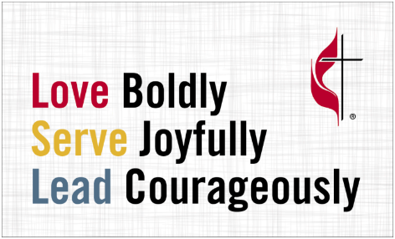

Week 2

Today’s Message
“Serve Joyfully”

Our Vision: Love God, Love your neighbor.
Our Mission: Seek God, Support each other,
Serve the World, to make disciples of Jesus Christ.

